

**Project Report-4**



Photography Business

**Group Members:**

Disha Shah (88)

Nikki Punjabi (78)

Zoebali Maknojia (50)

Zankhan Joshi (38)

**Goal for 4th fortnight :**

**Planned :**

We had planned to visit printing and developing labs to collect information about printing and developing department.

**Actual :**

We visited 2 printing and developing labs and they provided us information about their department.

**Documentation :**

Developing and Printing:

Business Worker:

Editor/Designer

Technician/Photo-developer in-charge

Sorter

Extra Staff

Entities:

Computer

Negative Scanner

Calibrator

Printing machines

Photographic Papers

Chemicals

Water

Printing:

Editors or Designers send the edited photos to this department where actual printing of photographs take place.

There are majorly 2 method involved:

1. Film Developing Process:
2. Turn on safelight. This is a dim red or orange light that will not expose your paper. You can buy this at most photographic supply stores. Turn off the room lights.
3. First stage is the pre-soaking stage where the film is soaked in water for some time. The time for which we have to soak the film will differ with the size of the film.
4. The developer has to be diluted with water according to the standard measurements and then poured into the tank. The diluted developer should be poured into the tank carefully to completely submerge the film. Once the developer is poured, start the timer and close the push-cap on the tank. Shake the tank by flipping it over for ten seconds after every minute. As the timer rings, pour out the used developer down the drain. Soaking the film in the developing solution is a crucial stage and the timing for which the film has to be soaked in the solution has to be accurately followed.
5. Use the stop bath solution (acetic acid) as a stop bath. Fill the tank with the stop bath solution, shake it and pour out the contents.
6. The Fixer helps to fix the image on the photographic film. Pour the fixing solution in the tank and shake it.
7. Once the fixing process is over, the film can be safely exposed to light. Clean it with fresh water to make sure there are no remnant traces of the fixing agent, since that ruin the entire process.
8. Pour a small amount of wetting agent into the bottom of the tank and fill the tank with water until the reel is submerged. Make sure to shake the bubbles off the surface of the film. After that, pour the contents out and take out the reel. Do not by any chance rinse the film now.
9. Lift the film off the reel and allow it to unfurl. Make sure that it doesn’t touch the ground or anything else. Hang it up for drying for 4 to 8 hours so it has sufficient time to dry and harden.
10. **Photo Development**:   
    Once the negative is ready, it has to be processed and transferred onto a photographic paper. The enlarger, which is an optical apparatus, is used to project the image of the negative onto a base, and finely control the focus, amount, and duration of light incident on the paper. A sheet of photographic paper is exposed to the enlarged image that projects from the negative. During exposure, the dodging and burning techniques can be used to adjust values of the image. These processes include reducing and increasing the amount of incident light selectively for part or all of the exposure time. After exposure the photographic printing paper is ready to be processed. The photographic paper is processed using chemicals in the following order:
11. The print is developed using a photographic developer
12. Rinsing with stop-bath
13. Fixing the image permanently with the use of photographic fixer
14. Washing to remove all the processing chemicals and then finally drying it

Developing:

Digital photographic printing equipment are designed to produce thousands of high quality prints per hour at relatively low cost. The machines use conventional color photographic printing paper, but instead of exposing it through a negative, they use digital exposure systems. The Fuji Frontier uses a scanning laser system, as does the Noritsu, while the Kodak/Kis machines use an LCD-based exposure system somewhat similar to those used in digital office projectors. Either way, after exposure the paper is processed using an integrated high-speed negative scanner.

Finally, the photos are sorted according their numbers and sent to the designing album department.

**Work flow – Printing and Developing Department**

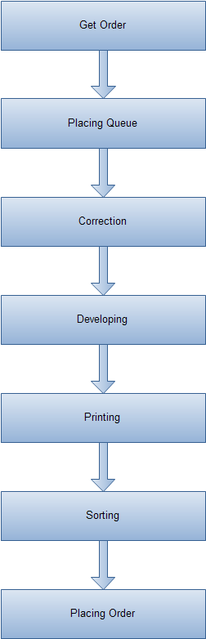

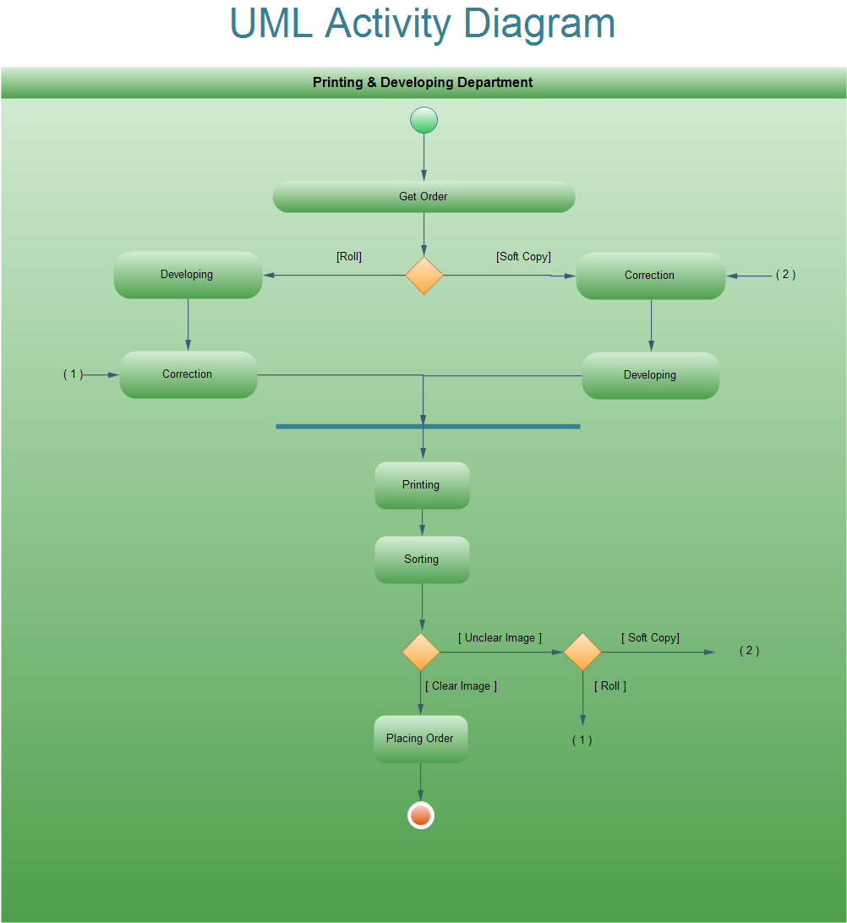

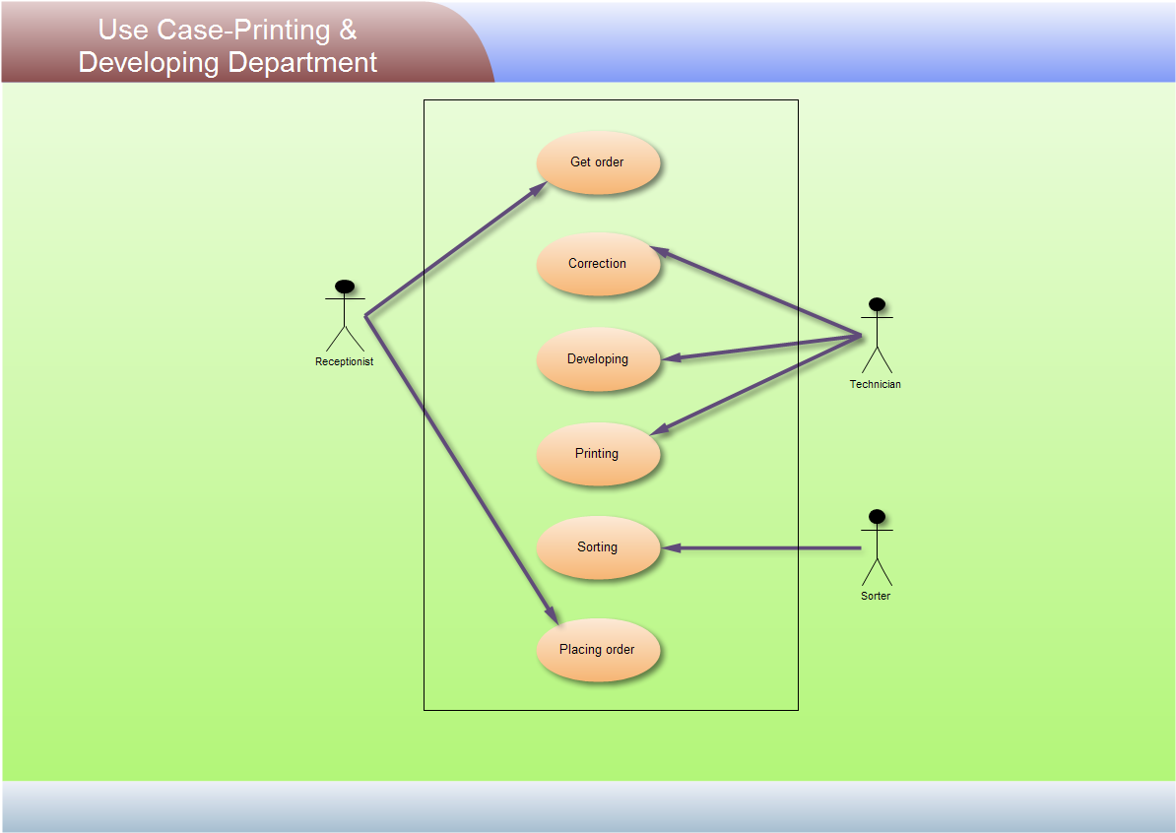

**Activity anticipated for next report :**

We are planning to get detailed information about rest of these departments.